  International Research Journal of Engineering and Technology (IRJET) |  | e-ISSN: 2395 -0056
Volume: 03 Issue: 02 | Feb-2016 | www.irjet.net | p-ISSN: 2395-0072

Online Training and Placement System

Mulla Kajal 1,Mahadik Awanti2, Pandharpatte Sonali3,Kalantre Rashmi4,Bansode Swapnali 5

Prof. Inamdar S. Y.,Dept. of Computer Science & Engineering, DACOE Karad, Maharashtra, India

--------------------------------------------------------------------- | ***---------------------------------------------------------------------
Abstract– | Our proposed system is vital to use in Colleges for
 | better Services in Placement.

Online Training and Placement system automates activities of Training and placement cell and place the best coordination between student.It provide student community to use collective intelligence to increase selection ratio and eases out process of creation of management information automatically. Online Training and Placement focuses on automation of placement cell.Authorising the CV, communicating about the various job openings to the student community, managing the corporate relationship for inviting them for the placements as well other activities, monitoring the progress of the selection process and communicating with different users.

KeyWord:

SMSIntegration,CV,Coordination,Authentication,Secure.

1. INTRODUCTION

In today’s world everyone is travelling for jobs after Completion of their graduation. It has became need for each and every student ,but for that they need to travel worldwide in searching of jobs.For simplicity of this whole hectic procedures we had proposed Online Training and Placement System because of earlier system is totally done manually by maintaining records,time consuming and very difficult to maintain coordination between student and companies.

In our proposed you will save time as well as money as its web based application.We can collect information of all college students and fetch them according to criteria given by company. We have three modules Admin/Training and Placement Officer(TPO),Student,Company. Admin has full access reserved over the system.Student’s can mainly upload their CV and can download resources by Admin/TPO and Company.Company can register and give their criteria for placement.

Objectives:

- To prepare students ready for industry employment.

- To provide Training and Employment opportunities for students .

- To provide industry institute interaction.

1.1 Need:

The need of our project Online Training and

Placement System are as:

- The main aim of developing this website was to reduce maximum chances of errors in manual work.

- Save time for the process.

- Also students get notified by the SMS instantly.

1.2 Implementation Details

Admin/TPO Module:

The admin module has an authority to add student and Company to the system and provide their valid id and password. The main user of the admin module is TPO of the college. TPO of the college will able to update details such as college name, college address, establish year, emp_id, branch, number of student, email_id, contact number, web address, etc. Admin.TPO module will able to give access through unique PRN of student to the system successfully by entering their PRN as

- user_id.Only those student will able to access the system, whose successfully allowed by the admin/TPO module. The various events related to the training and placement program is uploaded to the system by entering subject means event name

© 2016, IRJET | Impact Factor value: 4.45 | ISO 9001:2008 Certified Journal | Page 2582

International Research Journal of Engineering and Technology (IRJET) |  | e-ISSN: 2395 -0056
Volume: 03 Issue: 02 | Feb-2016 | www.irjet.net | p-ISSN: 2395-0072
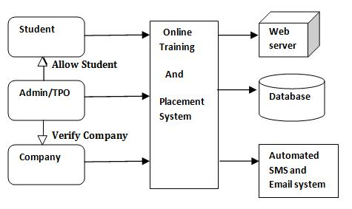

and text that contain detailed information about event. The user can able to change their password by using change password field. Event option shows the event name, date of event, information about the event. Company options display the company name and website of that company. The field about us in the menu bar contains information about the admin module. After the completion of task user will logout successfully by clicking on logout field at the top menu bar.

Student Module:

Student module deals with information of student. Student who has added by the administrator to the system successfully can only able to access the system with their valid user name and password provided by the administrator. First student should login into the system by entering PRN as their user name and password.

Student can able to update his information such as name, branch, year, aggregate marks, contact number, email, etc. by clicking on Update Details option and also upload their CV.The change password field is used by the student if he needs to change his password as same in the admin module. After completing task successfully by click on the Logout, student can successfully logout from the system.

Company Module:

Initially Company must need to login to the system by entering valid user_id and password provided by the administrator module. The recruiter updates his details like his company name, working criteria and information about itself. The Company will see the details about the college posted by the admin module to the system. The Company will also able to see the student details as name, branch, aggregate marks, passed out year etc.Company can change his password if he required by using the change password field. Mailing and messaging option is also available in Company module that contain email /messages received and send by the Admin/TPO. The menu bar at the top can consist of same field as previous module except that the about us field can contains information about the Company module. By clicking on logout field the Company can successfully logout from the system.

Figure1. Architecture Diagram

1.3Results

The Homepage is as shown in Figure 2 on which right side it contains Events and News are displaying.Left side of homepage contains links of signing up for Admin/TPO,Company and Student.The Menu bar contains Home,About,Student Registration etc options.
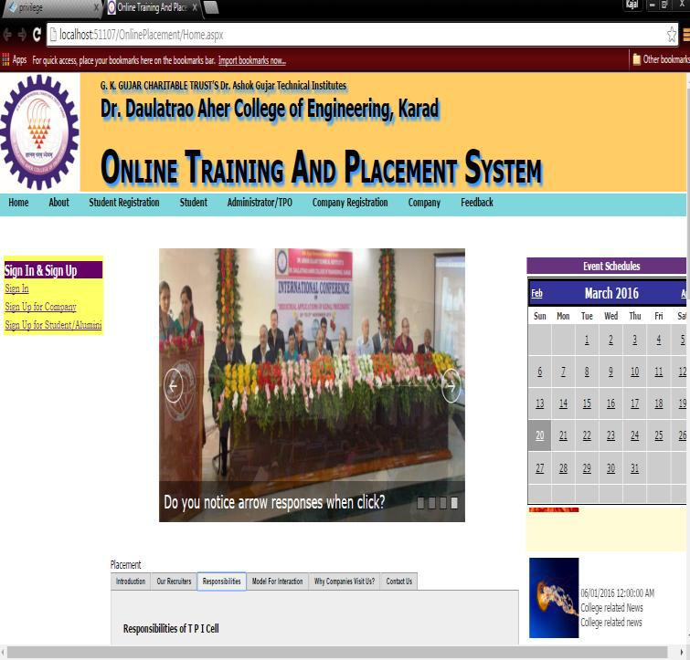

Figure 2.Homepage

SMS integration page is as shown in Figure 3 gives the instant messaging to notify Students as most of don’t go through Emails so we Provided both SMS and Email integration in our proposed system.These service can be used by Admin/TPO.

© 2016, IRJET | Impact Factor value: 4.45 | ISO 9001:2008 Certified Journal | Page 2583

International Research Journal of Engineering and Technology (IRJET) |  | e-ISSN: 2395 -0056
Volume: 03 Issue: 02 | Feb-2016 | www.irjet.net | p-ISSN: 2395-0072

REFERENCES
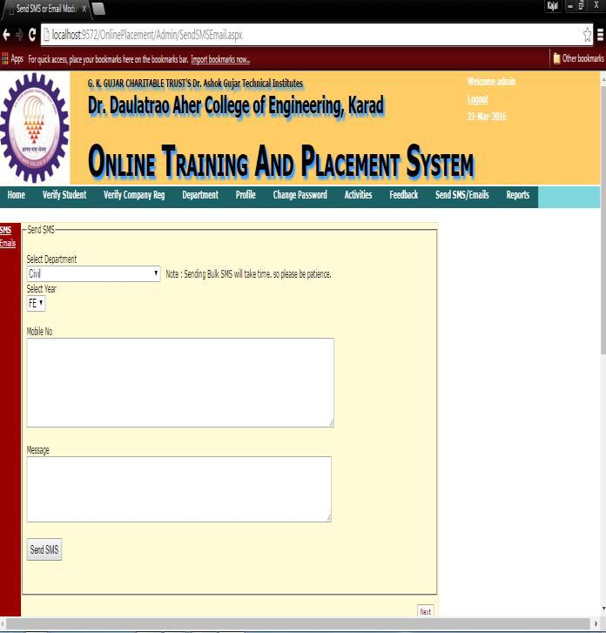

[1]www.codeproject.com.

[2] The Complete Reference “Crystal Reports 2008” by

George peck.

[3]Training and placement website of IIT,Patna.

[4] “Microsoft Visual Basic 2010” by Michael

Halvorson.

[5] Tynjälä, P., Perspective into learning at the workplace, Educational Research Review, 3, 2008, pp.130-154.

[6] “The Complete Reference ASP.NET” book by Robert Standefer III.

Figure 3

- CONCLUSIONS

Our proposed system work according to IEEE

paper.It can successfully login authorized person to

system and register them.In our system admin can

check the Student list those eligible according to

criteria given by the Company and notify them

instantly and update the information anytime

successfully.Our system is Secure and User-friendly for

all of three modules.

ACKNOWLEDGEMENT

It is our advantage to acknowledge with deep

sense of gratitude to our project guide Prof. Inamdar S.

Y. and our H.O.D Prof. Birnale M. A. whose supervision,

inspiration and valuable discussion has helped us to

complete our project. Their guidance proved to be the

most valuable to overcome all the complications in the

fulfillment of this mega project on “Online Training and

Placement System”.

We are thankful to Principal Dr. Jalindar R. Patil

for direct or indirect help in the completion of this

project. Last but not least, this acknowledgement

would be incomplete without rendering our sincere

gratitude to all those who have helped us in the

completion of this project.

© 2016, IRJET | Impact Factor value: 4.45 | ISO 9001:2008 Certified Journal | Page 2584

